**Indian Hotel Industry**

1.Introduction

The primary purpose of hotels is to provide travelers with shelter, food, refreshment, and similar services and goods, offering on a commercial basis things that are customarily furnished within households but unavailable to people on a journey away from home. Historically hotels have also taken on many other functions, serving as business exchanges, centers of sociability, places of public assembly and deliberation, decorative showcases, political headquarters, vacation spots, and permanent residences.

The hotel as an institution, and hotels as an industry, transformed travel in India, hastened the settlement of the continent, and extended the influence of urban culture.

India is a large market for travel and tourism. It offers a diverse portfolio of niche tourism products - cruises, adventure, medical, wellness, sports, MICE, eco-tourism, film, rural and religious tourism. India has been recognised as a destination for spiritual tourism for domestic and international tourists.

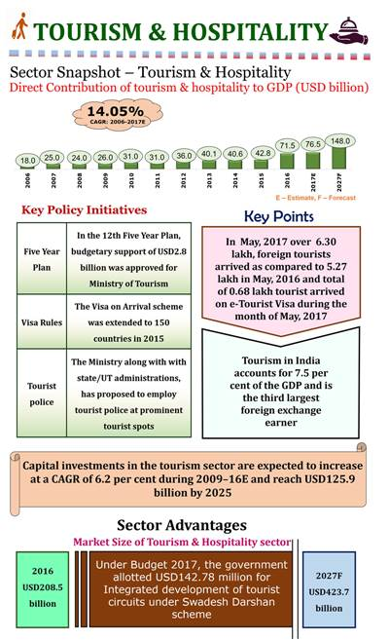

**The purpose of this project is to analyse the pricing strategy of hotels in the Indian hotel industry**. Many factors drive hotel room prices. The objective of this project is to identify the factors that matter the most. We evaluate whether the hotel room rent depends on external factors or internal factors.

2.Overview of study

Our field study concerns hotel prices in India , where we analyse how room rent varies according to external factors such as IsWeekend, IsNewYearEve, CityName, CityRank, IsMetroCity, IsTouristDestination and internal factors such as StarRating, HotelCapacity, HasSwimmingPool, etc.

As per world travel and tourism Council (WTTC), India is one of the favorite tourist destinations from the year 2009 and will continue to be one of the favorite till 2018. Further, the Travel and Tourism Competitiveness Report by World Economic Forum, has ranked India at the sixth place in tourism and hospitality.

In the long term, the demand-supply gap in India is very real and that there is need for more hotels. The shortage is especially true within the budget hotels and the mid-market hotels segment. There is an urgent need for budget and mid-market hotels in the country as travelers look for safe and affordable accommodation. Various domestic and international brands have made significant inroads into this space and more are expected to follow as the potential for this segment of hotels becomes more obvious.

As per a report by ICRA, the domestic hotel industry is estimated to touch US$ 1.8 billion by 2016, from US$ 0.8 billion presently. The growth is expected to come from the rise in online bookings. Hotel bookings is one of the least penetrated segments in the travel categories in India. Online bookings account for 16% of the hotel bookings currently and is expected to grow to 25% in 2016. It is estimated that 8.4 million Indians are likely to book hotels online by 2016, up from 3.5 million in 2014.

With a rise in online competition, popular models have come up with online travel agents (OTAs) offering a single marketplace for all travel-related needs. There are also seen meta search engines like TripAdvisor and MakeMyTrip, that operate like travel discovery platforms. Further, online accommodation reservation services like Oyo Rooms have gained popularity. Apart from this, branded hotels are seen operating direct bookings through their websites.

3.Data

For this study the data has been taken from the website www.hotels.in

This data comprises of the data from 42 cities in India , including the tourist destinations like Agra , Jaipur and metro cities like New Delhi , Mumbai. For the analysis of data it has been categorically been divided into internal and external factors to study their impact on the RoomRent at various locations. For simplicity, we picked the cheapest room with double occupancy.

**DATA DESCRIPTION**

**Notice that the dataset tracks hotel prices on 8 different dates at different hotels across different cities. Please browse the dataset.**

**Please understand the meaning of each column of the dataset.**

**Dependent Variable**

|  |  |  |
| --- | --- | --- |
| **DECISION VARIABLE** | **UNITS** | **MEANING** |
| **RoomRent** | **Rupees** | **Rent for the cheapest room, double occupancy, in Indian Rupees.**  **Some hotels have more than one type of double occupancy room. For simplicity, we picked the cheapest room with double occupancy.** |

If your problem could be written as a function y = f(x), RoomRent is your y variable.

You need to explain what factors drive the RoomRent set by hotels.

**External Factors**

**Many external factors can potentially influence the RoomRent. The dataset captures some of these external factors, as explained below.**

|  |  |  |
| --- | --- | --- |
| **VARIABLE** | **UNITS** | **MEANING** |
| **Date** | Text | **We have hotel room rent data for the following 8 dates for each hotel:**  **{Dec 31, Dec 25, Dec 24, Dec 18, Dec 21, Dec 28, Jan 4, Jan 8}**  **If a hotel is sold out on a given date, assume that the price of the hotel room on the date it is sold out is the maximum price from the sample of dates for which prices are available.** |
| **IsWeekend** | Dummy | **We use ‘0’ to indicate week days, ‘1’ to indicate weekend dates (Sat / Sun)** |
| **IsNewYearEve** | Dummy | ‘1’ for Dec 31, ‘0’ otherwise |
|  |  |  |
| **CityName** | Text | Name of the City where the Hotel is located   e.g. Mumbai` |
| **Population** | Number | **Population of the City in 2011 (See Table A1 below)** |
| **CityRank** | Dummy | Rank order of City by Population (e.g. Mumbai = 0, Delhi = 1, so on); (See Table A1) |
| **IsMetroCity** | Dummy | ‘1’ if CityName is {Mumbai, Delhi, Kolkatta, Chennai}, ‘0’ otherwise |
|  |  |  |
| **IsTouristDestination** | Dummy | We use ‘1’ if the city is primarily a tourist destination, ‘0’ otherwise. For example, Goa and Agra are primarily tourist destinations. We assume that most people who visit Goa and Agra and stay in their hotels are in these cities primarily for tourism. |

**Internal Factors**

**Many Hotel Features can influence the RoomRent. The dataset captures some of these internal factors, as explained below.**

|  |  |  |
| --- | --- | --- |
| **VARIABLE** | **UNITS** | **MEANING** |
| **HotelName** | Text | e.g. Park Hyatt Goa Resort and Spa |
| **StarRating** | Number | e.g. 5 |
| **Airport** | km | Distance between Hotel and closest major Airport |
| **HotelAddress** | Text | e.g. Arrossim Beach, Cansaulim, Goa |
| **HotelPincode** | Number | 403712 |
| **HotelDescription** | Text | e.g. 5-star beachfront resort with spa, near Arossim Beach |
| **FreeWifi** | Dummy | ‘1’ if the hotel offers Free Wifi, ‘0’ otherwise |
| **FreeBreakfast** | Dummy | ‘1’ if the hotel offers Free Breakfast, ‘0’ otherwise |
| **HotelCapacity** | Number | e.g. 242.  (enter ‘0’ if not available) |
| **HasSwimmingPool** | Dummy | ‘1’ if they have a swimming pool, ‘0’ otherwise |

4.Hypothesis

When it comes to deciding the price of hotel room various factors are taken into considerations. Therefore, we make the following hypothesis.

* H1

The Internal Factors have much greater influence in deciding Room Rent of Hotels than External factors.

* H2

For all the hotels in cities that are tourist destinations, their room rent has an inverse relation with IsMetrocity(whether a city is a metro city or not)

Usage of T.Test to check the validity of our Hypothesis

* For H1

As P-value is less than 0.05, we can reject the null hypothesis that the Internal Factors have same influence in deciding Room Rent of Hotels as External factors.

* For H2

As P-value is less than 0.05, we can reject the null hypothesis that for all the hotels in cities that are tourist destinations, their room rent is same whether a city is a metro city or not.

5.MODEL

We analysed are hypothesis using different models :

**H 1** :- **The Internal Factors have much greater influence in deciding Room Rent of Hotels than External factors.**

In order to test Hypothesis 1, we proposed the following models:

PREDICTING Room Rent FROM Internal Factors

Room Rent: Dependent variable

StarRating , HotelCapacity ,HasSwimmingPool: Independent variables

**Model 1**: RoomRent = b0 + b1*StarRating + b2*HotelCapacity +b3*HasSwimmingPool

We established the effect of StarRating , HotelCapacity ,HasSwimmingPool on the price of a hotel room with the simplest model .We estimated model, using linear least square to check for the internal factors.

PREDICTING Room Rent FROM External Factors

Room Rent: Dependent variable

IsNewYearEve,IsMetroCity,IsTouristDestination: Independent variables

**Model 2**: RoomRent = b0 +b1*IsNewYearEve+b2*IsMetroCity+b3*IsTouristDestination

We established the effect of IsNewYearEve,IsMetroCity,IsTouristDestinationon the price of a hotel room with the simplest model .We estimated model, using linear least square to check for the external factors.

Results

Model 1 fit the data better than Model 2, as indicated by the AIC. The AIC of Model 1 was less than the AIC of Model 2. Overall, we found Model 1 to be better than Model 2 in explaining the relationship between hotel room rent and various other factor. Thus, Model 1 is our 'best' ordinary least squares model

**H3 :- For all the hotels in cities that are tourist destinations, their room rent has an inverse relation with IsMetrocity(whether a city is a metro city or not)**

In order to test Hypothesis 2, we proposed the following models:

PREDICTING Room Rent of tourist destination hotel FROM IsMetroCity

Room Rent: Dependent variable

IsMetroCity: Independent variable

**Model 3**: RoomRent = b0 + b1*IsMetroCity

Results

We found empirical support for H2. The average room price of Non-Metro Cities was higher

as compared to the Metro Cities for all tourist destination hotel . The regression analysis using Ordinary Least Squares

yielded b1<0, with p<0.05.

**Conclusion**

This paper was motivated by the need for research that could improve our understanding of how various factors influence the pricing strategies in the hotel industry in India. The unique contribution of this paper is that we investigated:

Based On Internal Factors

Room rent increases by INR 2528 if there is a swimming pool , increases by INR 3597 for an increase of 1 in star rating and decreases by INR 15 as hotel capacity increases by 1.

Based On External Factors

For all the hotels in cities that are tourist destination , their Room rent decreases by INR 2049 if these cities are also a metro city

Room rent increases by INR 863 if it is a New Year Eve , increases by INR 2171if it is a tourist destination and decreases by INR 1416 if it is a metro city.

**Thus we can conclude that**

* While deciding room rent internal factors have a much greater influence than external factors.
* While deciding room rent of tourist destination metro cities will have less room rent than non metro cities

**Table 1: SUMMARY STATISTICS OF INDIAN HOTEL INDUSTRY**

|  |  |  |  |  |  |  |
| --- | --- | --- | --- | --- | --- | --- |
| City  Name | No.  Of  Hotels | Room  Rent  (mean) | Hotel  Capacity  (mean) | City  Rank | Star  Rating  (mean) | Is  Tourist  Destination |
| DELHI | 2048 | 4318 | 82 | 1 | 3.5 | Yes |
| JAIPUR | 768 | 7292 | 61 | 9 | 3.5 | Yes |
| MUMBAI | 712 | 6343.73 | 102 | 0 | 3.6 | Yes |
| BANGALORE | 656 | 4112.8 | 86 | 2 | 3.7 | No |
| GOA | 624 | 8170.8 | 48.8 | 18 | 3.2 | Yes |
| KOCHI | 608 | 6039.6 | 47.4 | 21 | 3.4 | Yes |
| ALL | 13232 | 5474 | 62.51 | NA | 3.45 | NA |

**Table 2: Regression Analysis in Indian Hotel Industry**

|  |  |  |  |  |
| --- | --- | --- | --- | --- |
| Model 1 | β | SE | t-Statistics | AIC value |
| Intercept | 6896 | 340 | -20 | 270742 |
| Star Rating | 3597 | 111 | 32 |  |
| Hotel Capacity | -15 | 1 | -15 |  |
| HasSwimmingPool | 2528 | 157 | 16 |  |
| Model 2 |  |  |  | 272765 |
| Intercept | 4245 | 119 | 35 |  |
| IsNewYearEve | 863 | 190 | 4 |  |
| IsMetroCity | -1484 | 141 | -10 |  |
| IsTouristDestination | 2213 | 139 | 15 |  |
| Model 3 |  |  |  | 192959 |
| Intercept | 6755 | 107 | 62 |  |
| IsMetrocity | -2049 | 185 | -11 |  |

*The Most expensive hotel of India*

*Rambagh Palace, Jaipur*

Having a Star rating of 5 and room rent of INR 322500



*The Cheapest hotel of India*

*Backpacker Panda Friends, Agra*

Having a star rating of 2 and room rent of INR 299

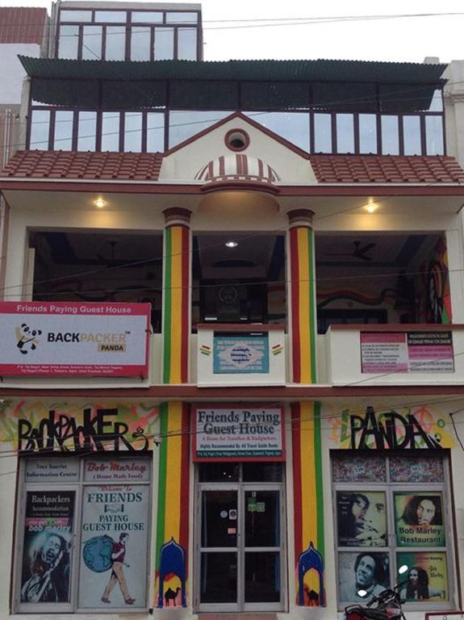

--------------------------------------------------------**The End**----------------------------------------------------------